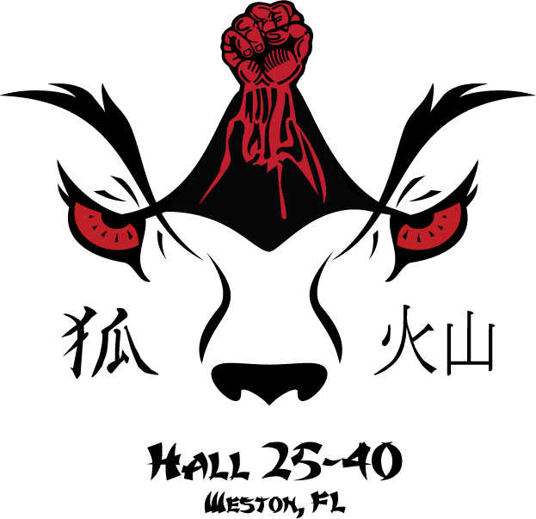 WOMEN’S SELF DEFENSE

Monday October 6, 2014

7pm-8:30

**Weston Dojo** 20200 Saddle Club Road Weston, FL 33327 **(Located inside Weston Regional Park)**

**Open to all friends and family**

**Be Prepared and Be Aware**

**Self Defense is a priority today!**

**$20**

Wear street clothes or exercise clothes

Open to all over 14 years old

For more information contact Sensei David Schopp <http://foxusagoju.com/contact/>